EXP.NO: 1 | Web Page C reation using HTML
DATE: 29/01/2025

AIM:
To create a web page that embeds a map with hotspots, frames, and links. The web page should be designed using HTML, incorporating embedded, external, and inline CSS for styling. This exercise aims to enhance understanding of integrating multimedia elements like maps, creating interactive hotspots, and organizing content using frames while applying different CSS techniques for styling.

ALGORITHM:

Create the HTML structure:
- Set up the basic HTML document with <!DOCTYPE html>, <html>, <head>, and
<body> tags.
- In the <head>, link the external CSS file (<link> tag), define the title, and include any metadata.
- In the <body>, create the necessary elements:
  - Frames: Use the <frameset> tag to create a frame layout (for older browsers, use <iframe> instead).
  - Map: Use the <img> tag to display a map.
  - Hotspots: Create clickable regions using the <map> and <area> tags.
  - Links: Add hyperlinks (<a>) to navigate to different parts of the page or external sites.

Create CSS Styles:
- External CSS: In a separate file, define styles such as colors, fonts, and layout for the entire page.
- Inline CSS: Use the style attribute within specific tags to apply styles (e.g., in <div> or <p> tags).
- Embedded CSS: Inside the <style> tag in the <head>, define styles for specific elements like the map, frames, and text.

Map with Hotspots:
- Use the <map> tag to create an image map.
- Define the <area> tag for each hotspot, specifying the coordinates (e.g., coords="x,y,x2,y2") for clickable areas on the map.

Frames:
- Use the <iframe> tag for embedding external content like a map or another webpage, with attributes such as src for the URL, width, and height.

Add Links:
- Inside the <body>, use the <a> tag to create links for navigation (for example, to link to specific parts of the page or external sites).

Test the Page:
- Test the webpage to check the functionality of frames, hotspots, and links. Ensure that the map hotspots are clickable and the linked content displays correctly.
- Ensure that the styles are applied properly using inline, embedded, and external CSS.

Code:

<!DOCTYPE html>

<html lang="en">

<head>

<meta charset="UTF-8">

<title>Department Website – AI & ML</title>

<style>

body{

font-family: Arial, sans-serif;

background-color:#f3f7fb;

margin:0;

}

header{

background:#4a148c;

color:#f3f7fb;

text-align:center;

padding:25px;

}

.main{

display:flex;

height:66vh;

}

.left,.center,.right{

padding:15px;

overflow:auto;

}

.left{width:30%;}

.center{width:40%;}

.right{width:30%;}

.box{

background:#f3f7fb;

border-radius:8px;

box-shadow:0 0 6px rgba(0,0,0,0.2);

}

h2{

color:#4a148c;

}

.map-container{

position:relative;

width:100%;

}

.map-container img{

width:100%;

border:2px solid #333;

}

.hotspot{

position:absolute;

width:16px;

height:16px;

background:red;

border-radius:50%;

cursor:pointer;

}

.lab{

top:55%;

left:45%;

}

.library{

top:40%;

left:60%;

}

iframe{

width:auto;

height: 180px;;

}

footer{

background:#2d1946;

color:white;

text-align:center;

padding:12px;

}

p{

font-family: Arial, Helvetica, sans-serif;

}

</style>

</head>

<body>

<header>

<h1>Department of Artificial Intelligence & Machine Learning</h1>

<p>AI & ML Department </p>

</header>

<div class="main">

<div class="left">

<h2 style="color: #4a148c;">About Department</h2>

<p style="font-family:Cambria, Cochin, Georgia, Times, 'Times New Roman', serif;"> <b>The Department of Artificial Intelligence and Machine Learning (AI & ML)</b> was

established to meet the growing demand for intelligent and data-driven technologies.

The department focuses on providing quality education in artificial intelligence,

machine learning, data science, and related emerging technologies.

It offers a strong blend of theoretical knowledge and practical skills through well-equipped laboratories,

experienced faculty, industry-oriented curriculum, and project-based learning. The department encourages

innovation, research, and ethical use of AI to prepare students for real-world challenges and higher

studies.</p>

<section class="box">

</div>

<div class="center">

<section class="box">

<h2>Facilities & Labs</h2>

<h3 id="lab">AI & ML Laboratory</h3>

<p style="color:blue;font-weight:bold;">Equipped with High-Performance Systems</p>

<p>Used for Deep Learning, Data Science and Research</p>

<iframe src="labs.jpg" ></iframe>

<br><br>

</section>

</div>

<div class="right">

<section class="box">

<h2>Department Infrastructure Map</h2>

<div class="map-container">

<iframe src="https://www.google.com/maps/embed?pb=!1m18!1m12!1m3!1d3887.4258203018458!2d80.00089457507708!3d13.008533387310248!2m3!1f0!2f0!3f0!3m2!1i1024!2i768!4f13.1!3m3!1m2!1s0x3a528c9ebac84723%3A0x18e2bf88dfefa3ed!2sRajalakshmi%20Engineering%20College!5e0!3m2!1sen!2sin!4v1770299649213!5m2!1sen!2sin" width="600" height="450" style="border:0;" allowfullscreen="" loading="lazy" referrerpolicy="no-referrer-when-downgrade"></iframe>

</div>

</section>

</section>

</div>

</div>

<footer>

<h3>Academic Links</h3>

<a href="https://www.coursera.org/" target="_blank">Coursera – AI Courses</a>| <a href="https://www.edx.org/" target="_blank">edX – Machine Learning</a>|<a href="https://ai.google/" target="_blank">Google AI</a>|<a href="https://openai.com/" target="_blank">OpenAI</a></li>

</footer>

</body>

</html>

OUTPUT:

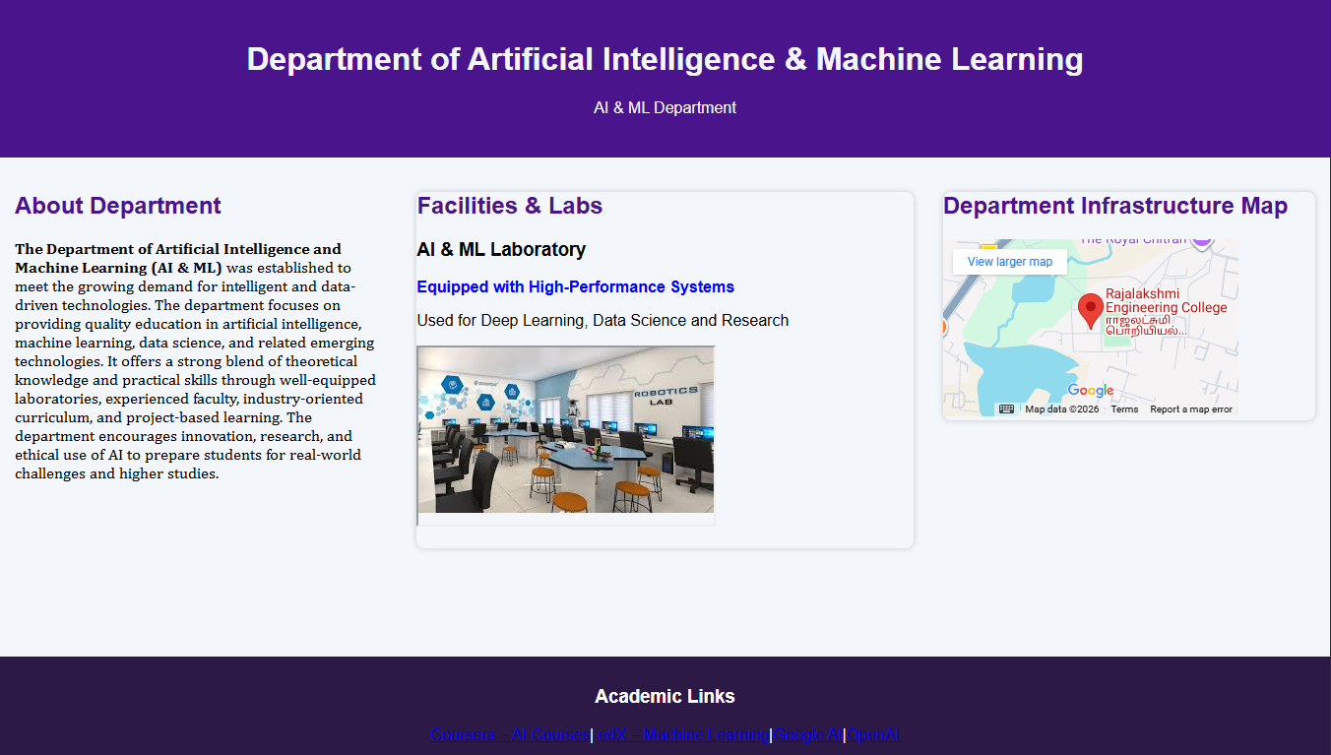

RESULT:
Html Page is created with embedded Chennai map along with hot spot, frames &
links.

